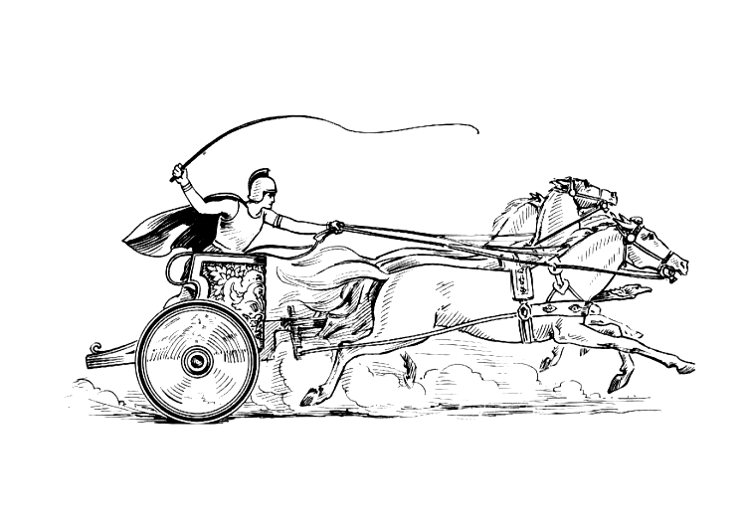
Parish Clerk: Mrs Elane Higgins
Registered Address:
Mancetter Memorial Hall
Old Farm Road
Mancetter.
CV9 1QN
Telephone: 01827 722552
Email: parishclerk@mancetterparishcouncil.gov.uk
Website: www.mancetter.gov.uk
Manduessedum - Mancetter Village
(Place of War Chariots)
Mancetter Parish Council
Serving the People of Mancetter and Ridge Lane

Mancetter Parish Council owns the picturesque Village Green, Mancetter Cemetery and Ridge Lane Allotments. It uses funds from cemetery fees and council tax to maintain these to a high standard; along with the historic St Peter's Churchyard, and the entrances to 11 miles of rights of way and rural footpaths.

Parish Council Precept
The Precept is the way that the Parish Council raises money to cover expenditure for the
year and is charged through the council tax system.
Based upon the approved budget, the Parish Council unanimously agreed to increase the total
annual precept to £37,000. This is an overall increase of £2,000 in total for the year, equal to
a percentage increase of 8.03%, as we have fewer households than last year.
Based upon the Council Tax Bands, the Parish Council increase FOR THE YEAR on bands
A-H are as follows: Band A £3.99, B £4.65, C £5.31, D £5.98, E £7.30, F £8.63,
G £9.95, H £11.95. Most Mancetter Parish properties fall within bands A-C, which is a
monthly increase of 33p, 39p and 44p respectively.

Mancetter Parish Council have been working with Nuneaton Signs, residents and local
community groups to create some new signage on the approaches to both villages.
Promoting our heritage is an important way of maintaining our cultural identity. We hope you
like them. In other news, a pedestrian puffin crossing has finally been approved for
Nuneaton Road in Mancetter. More details to follow.
WE ALSO STILL HAVE A VACANCY FOR A PARISH COUNCILLOR, so please
get in touch to find out how you can get involved. Thank you.


